PATHFINDING ALGORITHM VISUALIZER

A MINI PROJECT REPORT

*Submitted by*

***MOHAMED AASHIK . N (910718104019) SATHISH KUMAR.N (910718104025)***

***ARJUN.M (910718104004)***

*in*

COMPUTER SCIENCE AND ENGINEERING



**K.L.N. COLLEGE OF INFORMATION TECHNOLOGY POTTAPALYAM**

1

## AUGUST 2021

**K.L.N. COLLEGE OF INFORMATION TECHNOLOGY**

**BONAFIDE CERTIFICATE**

Certified that this project report **“PATHFINDING ALGORITHM VISUALIZER”** is the bonafide work of **“MOHAMED AASHIK.N (910718104019), SATHISH KUMAR.N (910718104025),** *and* **ARJUN.M**

**(910714104004)”** who carried out the project work under my supervision.

|  |  |
| --- | --- |
| **SIGNATURE** | **SIGNATURE** |
| **Mr.G.GANESAN M.E(CSE).,M.S (IT)** | **Mr.P.AJEETH., M.E.** |
| **HEAD OF THE DEPARTMENT** | **SUPERVISOR** |
| Computer Science & Engineering, | **ASSISTANT PROFESSOR** |
| K.L.N.College of Information Technology | Computer Science & Engineering, |
| Pottapalayam, | K.L.N.College of Information Technology |
| Sivagangai-630 612, | Pottapalayam,Sivagangai-630 612, |
| Tamil Nadu. | Tamil Nadu. |

## ACKNOWLEDGEMENT

Any work would be unfulfilled without a word of thanks .We hereby takes pleasure in acknowledging the people who guided us throughout our work.

We express our sincere thanks and deep sense of gratitude to

## Dr.K.R.YOGANATHAN D.C.E.,B.E.-CIVIL., M.E.-STRUCT.,PH.D.

Principal, K.L.N College of Information Technology, for giving us the opportunity of doing this project.

We take privilege to extend our sincere thanks to our beloved Head of the Department **Mr.G.GANESAN M.E(CSE).,M.S (IT),** for his commendable support and encouragement and for leading us towards the zenith for success.

We also express our heartfelt gratitude to our internal guide **Mrs.T.T.Mathangi M.E,** who was always a constant source of inspiration and encouragement to us throughout the project.

We express our sincere thanks to the project coordinators for their continuous support throughout our project.

We wish to convey our sincere thanks to all the teaching and non teaching staff of the Department of CSE, K.L.N College of Information Technology for their support.

Last but not the least, we would like to extend our humble thanks to our beloved parents for their continuous encouragement throughout this project.

## ABSTRACT

Visualizations of algorithms contribute to improving computer science education. The process of teaching and learning of algorithms is often complex and hard to understand the problem. Visualization is a useful technique for learning in any computer science course. In this paper, an e-learning tool for shortest paths algorithms visualization is described. The Pathfinding algorithms are important because they are used in applications like google maps, satellite navigation systems, routing packets over the internet. The usage of pathfinding algorithms isn't just limited to navigation systems. The overarching idea can be applied to other applications as well. As a beginner’s step to algorithm and starting to understand how they work I decided to make this visualizer that shows in action how the pathfinding algorithm works in action. The understanding of this algorithm gives you the base idea of how navigation tools are implemented. In this visualizer, I have a grid page that has nodes that helped to pinpoint where to start and the endpoint. Also we can draw a line between the start node and the end node to make a barrier and see how our path will avoid it to reach the end node. To make this visualizer you need to be at least an intermediate level in front end programming (HTML, Nodes, CSS) and a good understanding of some pathfinding algorithm.

## TABLE OF CONTENTS ABSTRACT

**LIST OF FIGURES**

|  |  |  |
| --- | --- | --- |
| **CHAPTER**  **NO** | **TITLE** | **PAGE NO** |
| 1 | **INTRODUCTION** | 1 |
| 2 | **PROBLEM DEFINITION** | 1 |
| 3 | **PROJECT GOALS & OBJECTIVES** | 2 |
| 4 | **PATHFINDING ALGORITHMS** | 3 |
|  | 4.1 DIJKSTRA’S ALGORITHM | 3 |
|  | 4.2 A STAR ALGORITHM | 6 |
|  | 4.3 GREEDY BEST-FIRST SEARCH | 9 |
|  | 4.4 BREADTH-FIRST SEARCH | 11 |
|  | 4.5 DEPTH-FIRST SEARCH | 13 |
| 5 | **RESULTS** | 16 |

|  |  |  |
| --- | --- | --- |
| 7 | **PERFORMANCE ANALYSIS AND**  **COMPARISION** | 17 |
| 8 | **CONCLUSION** | 23 |
| 9 | **REFERENCES** | 23 |

**CHAPTER 1 INTRODUCTION**

Pathfinding or pathing is the plotting, by a computer application, of the shortestroute between two points. It is a more practical variant on solving mazes.This field of research is based heavily on Dijkstra's algorithm for finding theshortest path on a weighted graph.

Pathfinding is closely related to the shortest path problem, within graph theory,which examines how to identify the path that best meets some criteria (shortest,cheapest, fastest, etc) between two points in a large network.At its core, a pathfinding method searches a graph by starting at one vertex and exploring adjacent nodes until the destination node is reached, generally with theintent of finding the cheapest route. Although graph searching methods such as a breadth- first search would find aroute if given enough time, other methods, which "explore" the graph, would tendto reach the destination sooner.An analogy would be a person walking across a room; rather than examiningevery possible route in advance, the person would generally walk in the directionof the destination and only deviate from the path to avoid an obstruction, andmake deviations as minor as possible.

## CHAPTER 2 PROBLEM DEFINITION

Nowadays many students have good CGPA but they are rejected in coding interviews and don't have jobs. Because they have been struggling for a year to learn algorithms and still can't pass any technical interviews. Are algorithms hard to learn? Algorithms are probably one of the harder courses in your comp sci. degree, but it's totally doable. What makes it so difficult compared to other courses is how much intuition is involved in designing/analyzing algorithms.

Pathfinding algorithms are important because they are used in applications like google maps, satellite navigation systems, routing packets over the internet. The usage of pathfinding algorithms isn't just limited to navigation systems. The overarching idea can be applied to other applications as well. But many of the students just study the algorithm but not having an idea about the algorithm. This visualizer help students to visualize and get an idea about how algorithms are work

1

and where we use this algorithm. Many of students easily know it and crack the interviews efficiently.

## CHAPTER 3

**PROJECT GOALS AND OBJECTIVES**

The most important factor for this project to visualize algorithm to easily understand by students.

In this section, the overall working of the project has been described. How the project started and how the project works and how the various phases of project were carried out and the challenges faced at each level. What does the project do? At its core, a pathfinding algorithm seeks to find the shortest path between two points. This project visualizes various pathfinding algorithms in action, and more! All of the algorithms on this project are adapted for a 2D grid, where 90 degree turns have a "cost" of 1 and movements from a node to another have a "cost" of 1.

Picking an Algorithm:

Choose an algorithm from the "Algorithms" drop-down menu. Note that some algorithms are unweighted, while others are weighted. Unweighted algorithms do not take turns or weight nodes into account, whereas weighted ones do.

Objectives of the project:

* It can be used as a E learning tool to understand Algorithms.
* It is used in finding Shortest Path.
* It is used in the telephone network.
* It is used in IP routing to find Open shortest Path First.
* It is used in geographical Maps to find locations of Map which refers to vertices of graph.
* We can make a GPS system which will guide you to the locations.
* Search engine crawlers are used BFS to build index. Starting from source page, it finds all links in it to get new pages.
* In peer-to-peer network like bit-torrent, BFS is used to find all neighbor nodes.
* As users of wireless technology, people demand high data rates beyond GigaBytes per second for Voice, Video and other applications. There are many standards to achieve data rates beyond GB/s. One of the standards is MIMO(Multi input Multi output).MIMO employs K-best Algorithm(which isa Breadth-First Search

algorithm) to find the shortest partial euclidian distances.

## CHAPTER 4 PATHFIND ALGORITHMS

* 1. **Dijkstra's algorithm** is an algorithm for finding the shortest paths between nodes in a weighted graph. We'll use the new addEdge and addDirectedEdge methods to add weights to the edges when creating a graph. Let us look at how this algorithm works −
     + Create a distance collection and set all vertices distances as infinity except the source node.
     + Enqueue the source node in a min-priority queue with priority 0 as the distance is 0.
     + Start a loop till the priority queue is empty and dequeue the node with the minimum distance from it.
     + Update the distances of the connected nodes to the popped node if "current node distance + edge weight < next node distance", then push the node with the new distance to the queue.
       - What this algorithm basically does is assumes all nodes are at an infinite distance from the source. Then it starts taking the edges in consideration and

keeps track of distances of nodes from the source updating the same if it finds a lower cost path along the way.

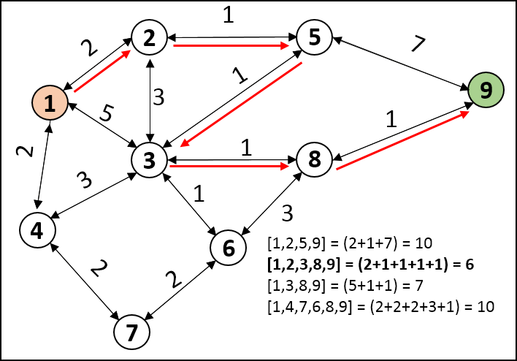

Let us look at this implementation in code (Javascipt) –

djikstraAlgorithm(startNode) { let distances = {};

// Stores the reference to previous nodes let prev = {};

let pq = new PriorityQueue(this.nodes.length * this.nodes.l ength);

// Set distances to all nodes to be infinite except startNo

de

distances[startNode] = 0;

pq.enqueue(startNode, 0); this.nodes.forEach(node => {

if (node !== startNode) distances[node] = Infinity; prev[node] = null;

});

while (!pq.isEmpty()) {

let minNode = pq.dequeue(); let currNode = minNode.data; let weight = minNode.priority;

this.edges[currNode].forEach(neighbor => {

let alt = distances[currNode] + neighbor.weight; if (alt < distances[neighbor.node]) {

distances[neighbor.node] = alt; prev[neighbor.node] = currNode; pq.enqueue(neighbor.node, distances[neighbor.node]

);

}

});

}

return distances;

}

## OUTPUT:

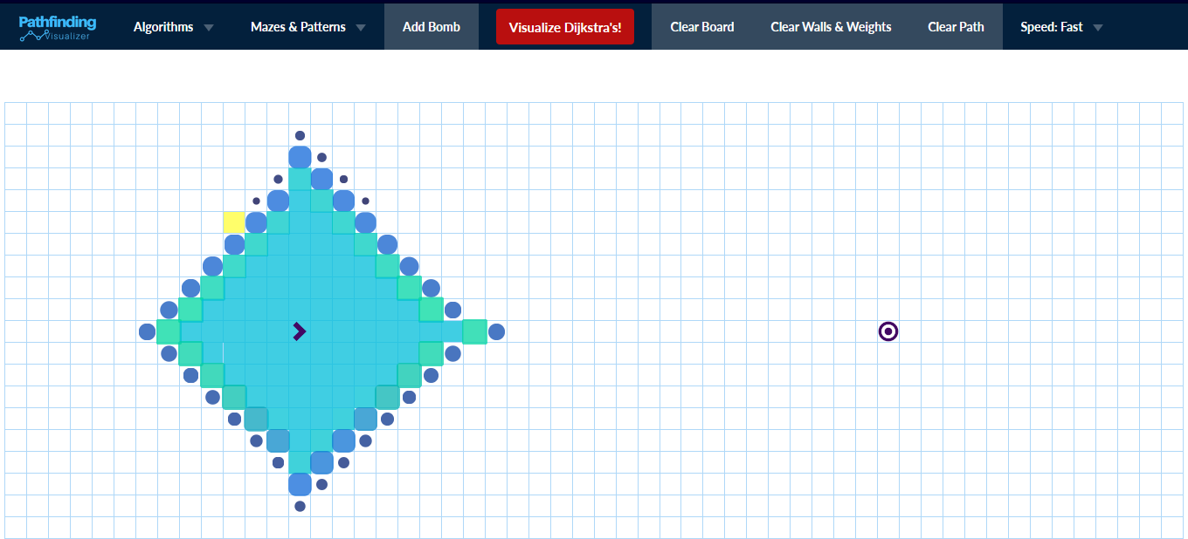

1. **finding shortest path**

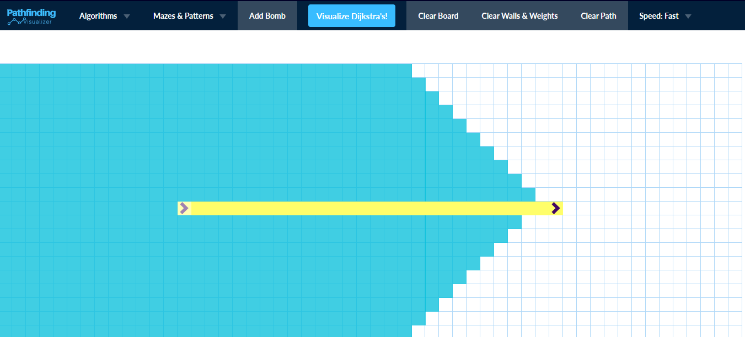

1. **The shortest path**

.

# **A Star Algorithm** is an algorithm used to solve the shortest path problem in a graph. This means that given a number of nodes and the edges between them as well as the “length” of the edges (referred to as “weight”) and a heuristic (more on that later), the A* algorithm finds the shortest path from the specified start node to all other nodes. Nodes are sometimes referred to as vertices (plural of vertex) - here, we’ll call them nodes.

In more detail, this leads to the following Steps:

1. Initialize the distance to the starting node as 0 and the distances to all other nodes as infinite
2. Initialize the priority to the starting node as the straight-line distance to the goal and the priorities of all other nodes as infinite
3. Set all nodes to “unvisited”
4. While we haven’t visited all nodes and haven’t found the goal node:
   1. Find the node with currently lowest priority (for the first pass, this will be the source node itself)
   2. If it’s the goal node, return its distance
   3. For all nodes next to it that we haven’t visited yet, check if the currently smallest distance to that neighbor is bigger than if we were to go via the current node
   4. If it is, update the smallest distance of that neighbor to be the distance from the source to the current node plus the distance from the current node to that neighbor, and update its priority to be the distance plus its straight-line distance to the goal node.

Consider the following graph:

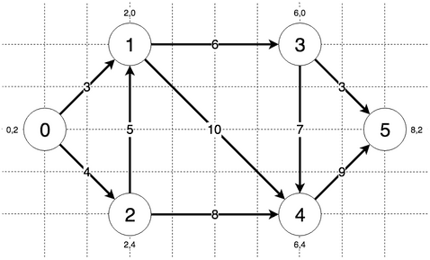

const aStar = function (graph, heuristic, start, goal) { var distances = [];

for (var i = 0; i < graph.length; i++) distances[i] = Number.MAX_VALUE; distances[start] = 0;

var priorities = [];

for (var i = 0; i < graph.length; i++) priorities[i] = Number.MAX_VALUE; priorities[start] = heuristic[start][goal];

var visited = []; while (true) {

var lowestPriority = Number.MAX_VALUE; var lowestPriorityIndex = -1;

for (var i = 0; i < priorities.length; i++) {

if (priorities[i] < lowestPriority && !visited[i]) { lowestPriority = priorities[i]; lowestPriorityIndex = i;

}

}

if (lowestPriorityIndex === -1) { return -1;

} else if (lowestPriorityIndex === goal) { return distances[lowestPriorityIndex];

}

for (var i = 0; i < graph[lowestPriorityIndex].length; i++) { if (graph[lowestPriorityIndex][i] !== 0 && !visited[i]) {

if (distances[lowestPriorityIndex] + graph[lowestPriorityIndex][i] < dist ances[i]) {

dex][i];

}

}

distances[i] = distances[lowestPriorityIndex] + graph[lowestPriorityIn priorities[i] = distances[i] + heuristic[i][goal]; }

visited[lowestPriorityIndex] = true;

}

};

module.exports = {aStar};

The steps the algorithm performs on this graph if given node 0 as a starting point and node 5 as the goal, in order, are:

1. Visiting node 0 with currently lowest priority of 8.0
2. Updating distance of node 1 to 3 and priority to 9.32455532033676
3. Updating distance of node 2 to 4 and priority to 10.32455532033676
4. Visiting node 1 with currently lowest priority of 9.32455532033676
5. Updating distance of node 3 to 9 and priority to 11.82842712474619
6. Updating distance of node 4 to 13 and priority to 15.82842712474619
7. Visiting node 2 with currently lowest priority of 10.32455532033676
8. Visiting node 3 with currently lowest priority of 11.82842712474619
9. Updating distance of node 5 to 12 and priority to 12.0 10.Goal node found!

OUTPUT:

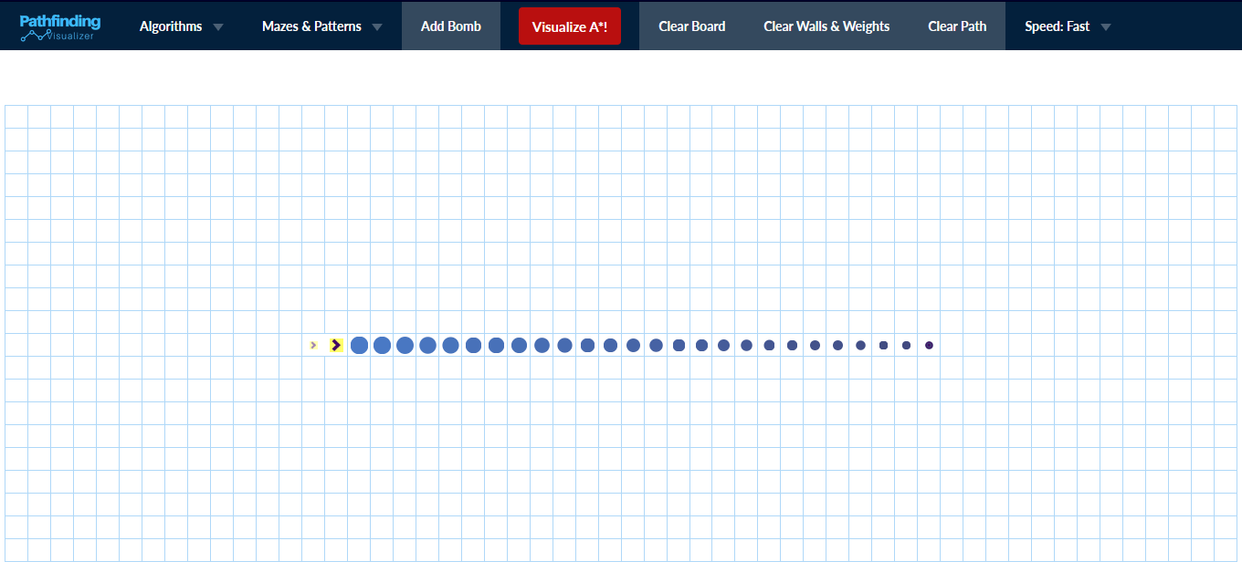

## finding shortest path

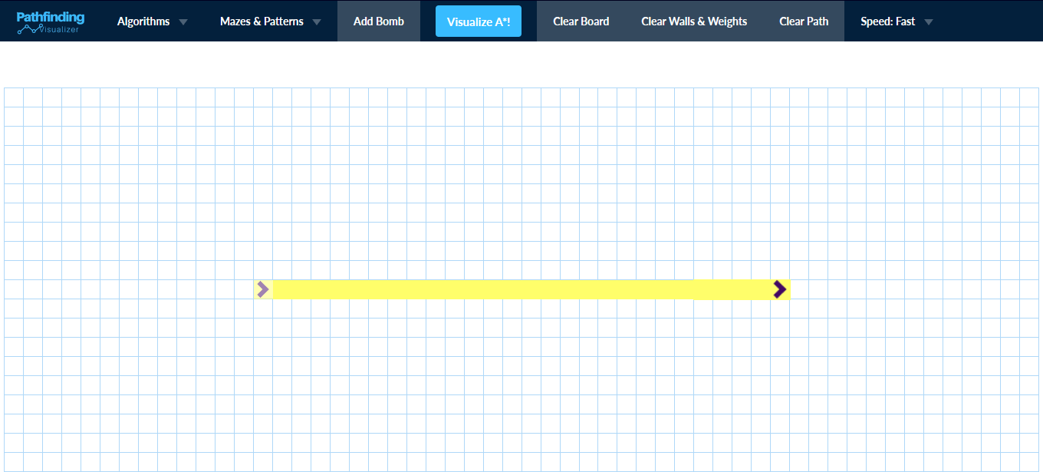

* 1. **The shortest path**
  2. **GREEDY BEST-FIRST SEARCH -** In BFS and DFS, when we are at a node, we can consider any of the adjacent as next node. So both BFS and DFS blindly explore paths without considering any cost function. The idea of Best First Search is to use an evaluation function to decide which adjacent is most promising and then explore. Best First Search falls under the category of Heuristic Search or Informed Search.

We use a priority queue to store costs of nodes. So the implementation is a variation of BFS, we just need to change Queue to PriorityQueue.

PSEUDO CODE:

**Best-First-Search**(Grah g, Node start)

1. Create an empty PriorityQueue PriorityQueue **pq**;
2. Insert "start" in pq. pq.insert(start)
3. Until PriorityQueue is empty

u = PriorityQueue.DeleteMin If u is the goal

Exit Else

Foreach neighbor v of u If v "Unvisited"

Mark v "Visited" pq.insert(v)

Mark u "Examined" End procedure

Let us consider the below example.

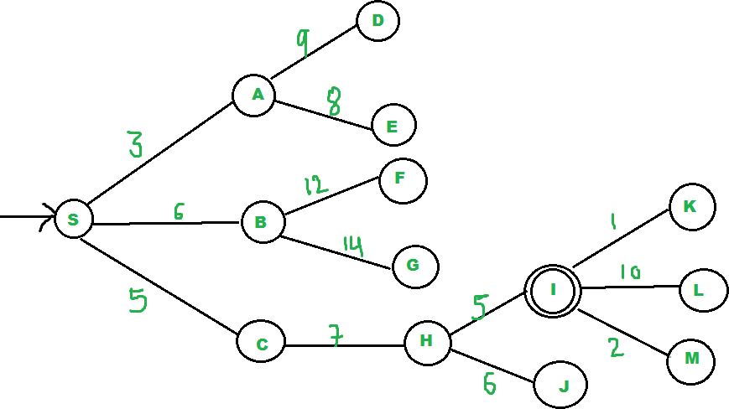

OUTPUT:

We start from source "S" and search for goal "I" using given costs and Best First search.

pq initially contains S

We remove s from and process unvisited neighbors of S to pq.

pq now contains {A, C, B} (C is put before B because C has lesser cost)

We remove A from pq and process unvisited neighbors of A to pq.

pq now contains {C, B, E, D}

We remove C from pq and process unvisited neighbors of C to pq.

pq now contains {B, H, E, D}

We remove B from pq and process unvisited neighbors of B to pq.

pq now contains {H, E, D, F, G}

We remove H from pq. Since our goal "I" is a neighbor of H, we return.

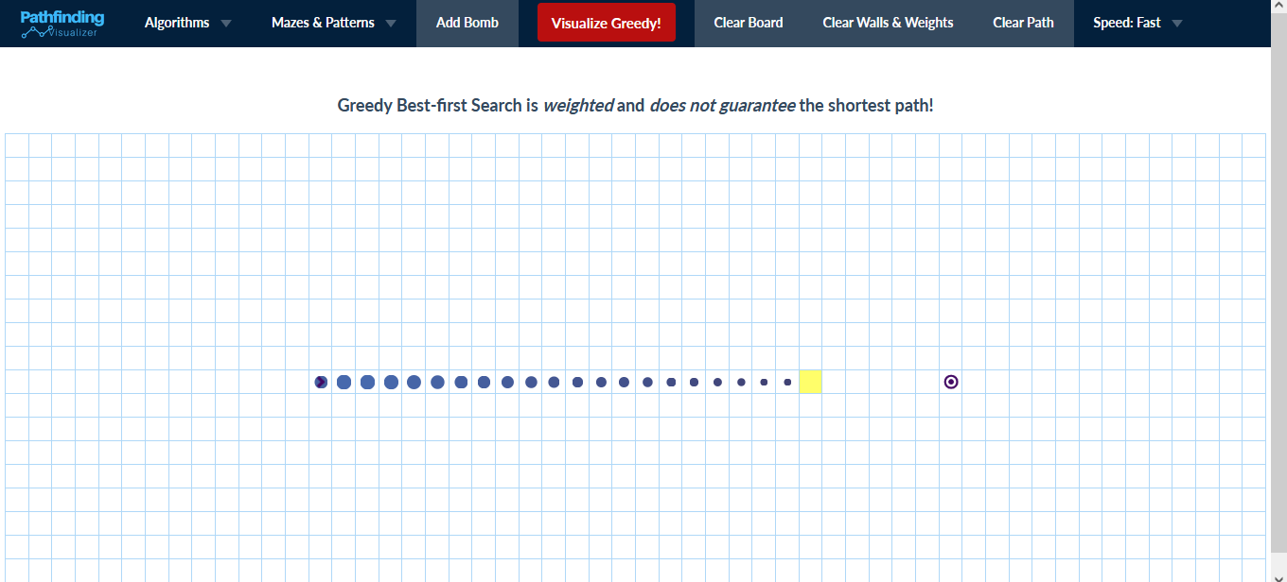

## finding shortest path

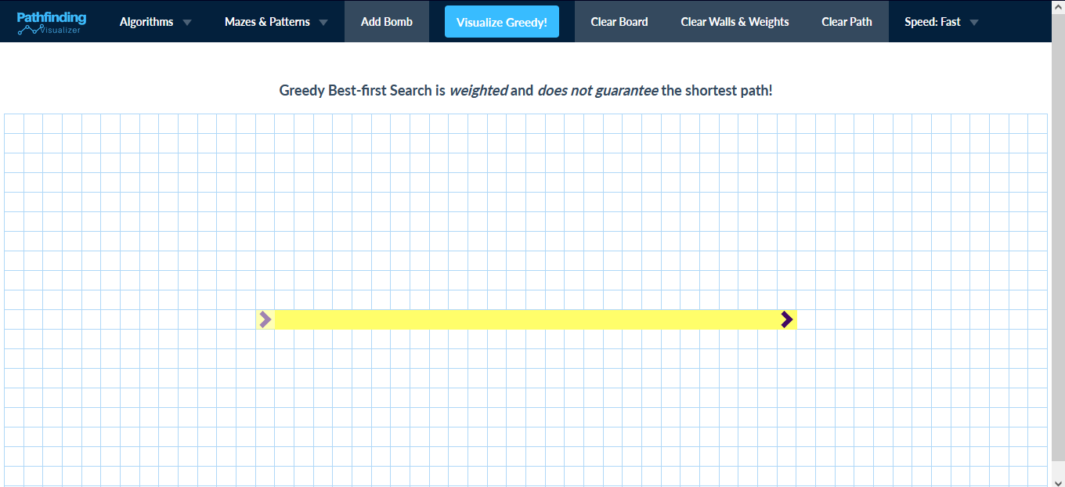

* 1. **The shortest path**
  2. **BREADTH-FIRST SEARCH** for a graph is similar to Breadth First Traversal of a tree .The only catch here is, unlike trees, graphs may contain cycles, so we may come to the same node again. To avoid processing a node more than once, we use a boolean visited array. For simplicity, it is assumed that all vertices are reachable from the starting vertex.

For example, in the following graph, we start traversal from vertex 2. When we come to vertex 0, we look for all adjacent vertices of it. 2 is also an adjacent vertex of 0. If we don’t mark visited vertices, then 2 will be processed again and it will become a non-terminating process. A Breadth First Traversal of the following graph is 2, 0, 3, 1.

BFS(node) {

// Create a Queue and add our initial node in it let q = new Queue(this.nodes.length);

let explored = new Set(); q.enqueue(node);

// Mark the first node as explored explored. add(node);

// We'll continue till our queue gets empty while (!q.isEmpty()) {

let t = q.dequeue();

this.edges[t].filter(n => !explored.has(n)).forEach(n => { ex plored.add(n);

q.enqueue(n);

});

}

}

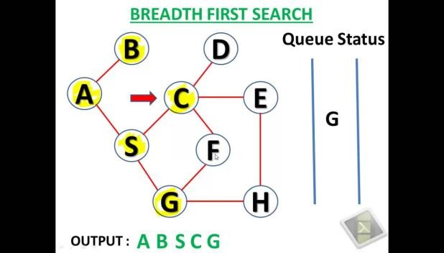

**OUTPUT:**

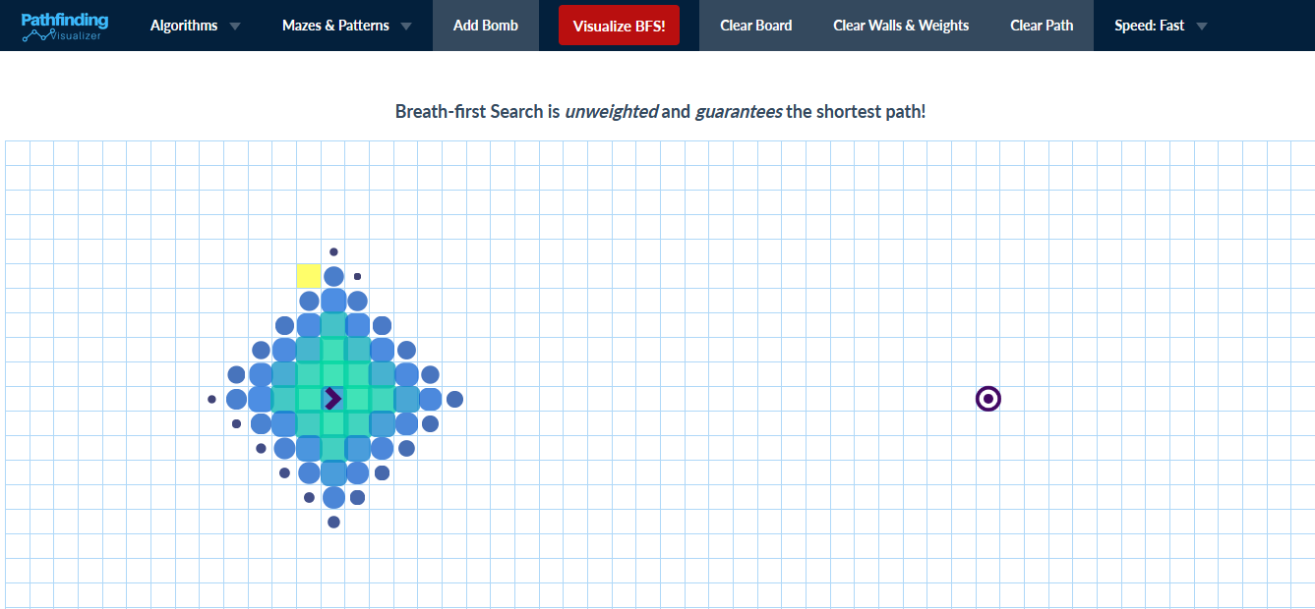

1. **finding shortest path**

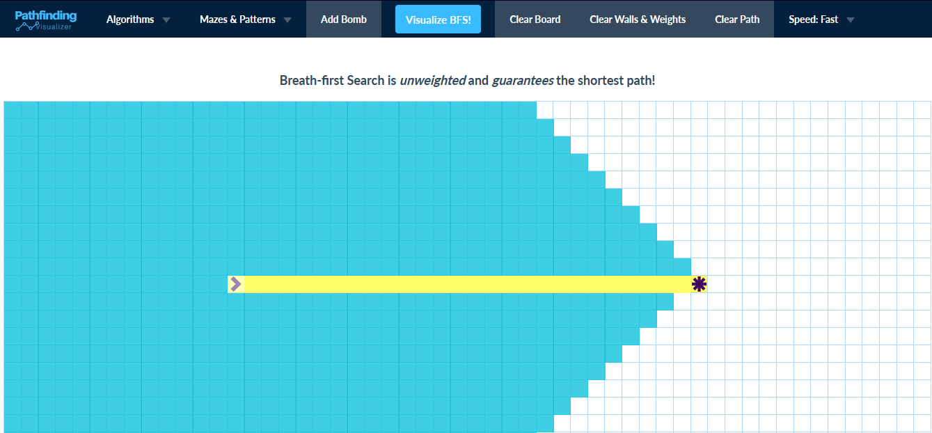

1. **The shortest path**
   1. **DEPTH-FIRST SEARCH -** for a graph is similar to Depth First Search Tree The only catch here is, unlike trees, graphs may contain cycles, a node may be visited twice. To avoid processing a node more than once, use a boolean visited array.
      * **Approach:** Depth-first search is an algorithm for traversing or searching tree or graph data structures. The algorithm starts at the root node (selecting some arbitrary node as the root node in the case of a graph) and explores as far as possible along each branch before backtracking. So the basic idea is to start from the root or any arbitrary node and mark the node and move to the adjacent unmarked node and continue this loop until there is no unmarked adjacent node. Then backtrack and check for other unmarked nodes and traverse them. Finally, print the nodes in the path.

## Algorithm:

1. Create a recursive function that takes the index of the node and a visited array.
2. Mark the current node as visited and print the node.
3. Traverse all the adjacent and unmarked nodes and call the recursive function with the index of the adjacent node.

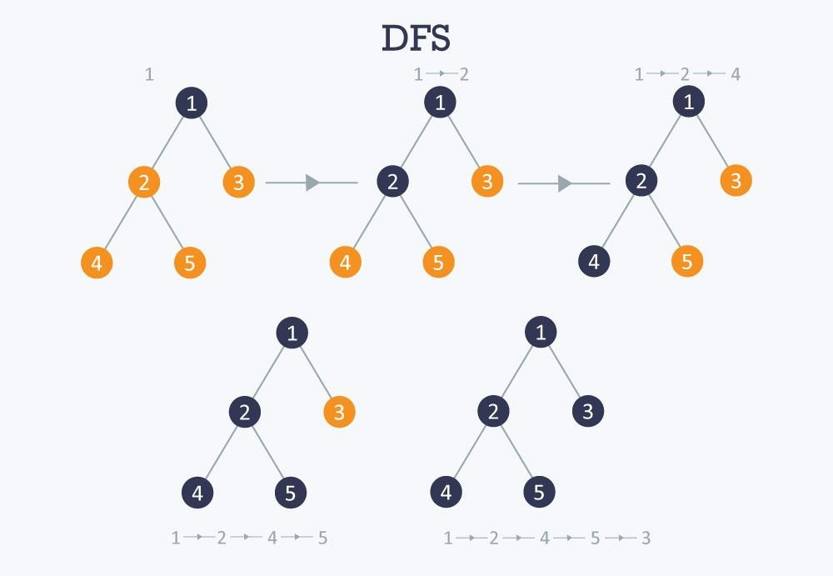

DFS(node) {

// Create a Stack and add our initial node in it let s = new Stack(this.nodes.length);

let explored = new Set(); s.push(node);

// Mark the first node as explored explored.add(node);

// We'll continue till our Stack gets empty while (!s.isEmpty()) {

let t = s.pop();

// Log every element that comes out of the Stack console.log(t);

// 1. In the edges object, we search for nodes this node is directly connected to.

// 2. We filter out the nodes that have already been explor

ed.

// 3. Then we mark each unexplored node as explored and pus

h it to the Stack. this.edges[t]

.filter(n => !explored.has(n))

.forEach(n => { explored.add(n); s.push(n);

});

}

}

## OUTPUT:

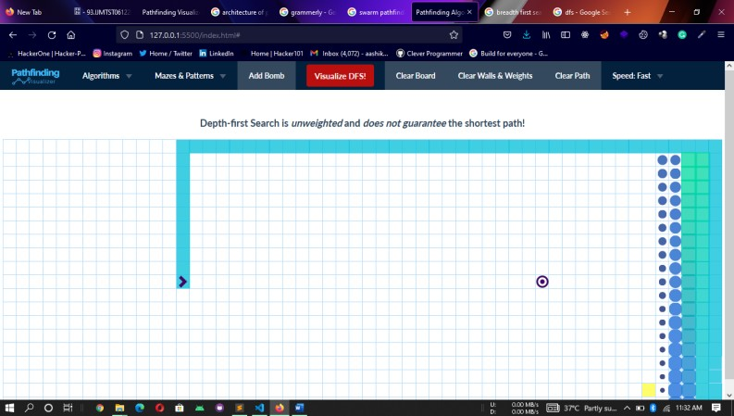

1. **finding shortest path - I**

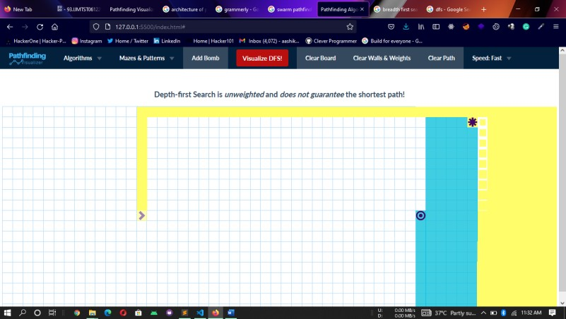

1. **finding shortest path - II**

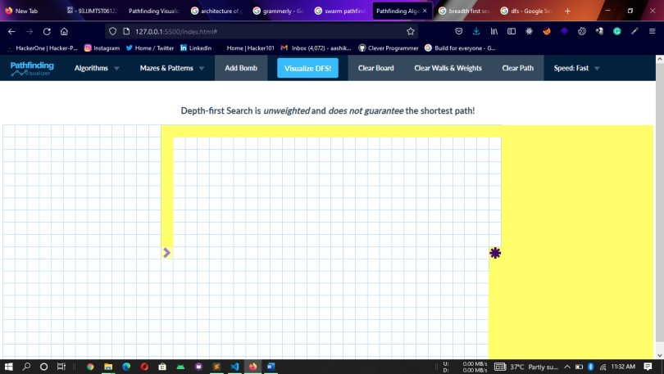

1. **The shortest path - II**

**CHAPTER 5 RESULTS**

* FirstlyClick on Get started.

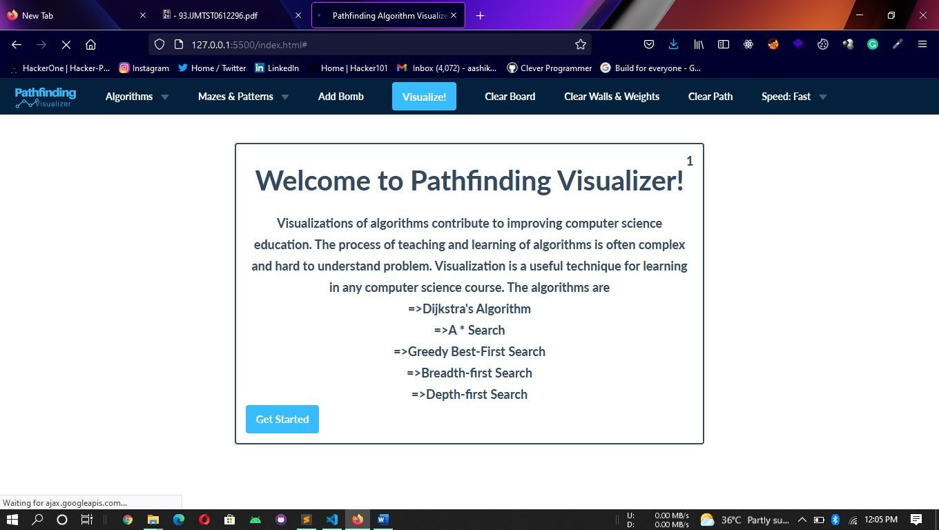

* Select Algorithm in Algorithms drop down box.

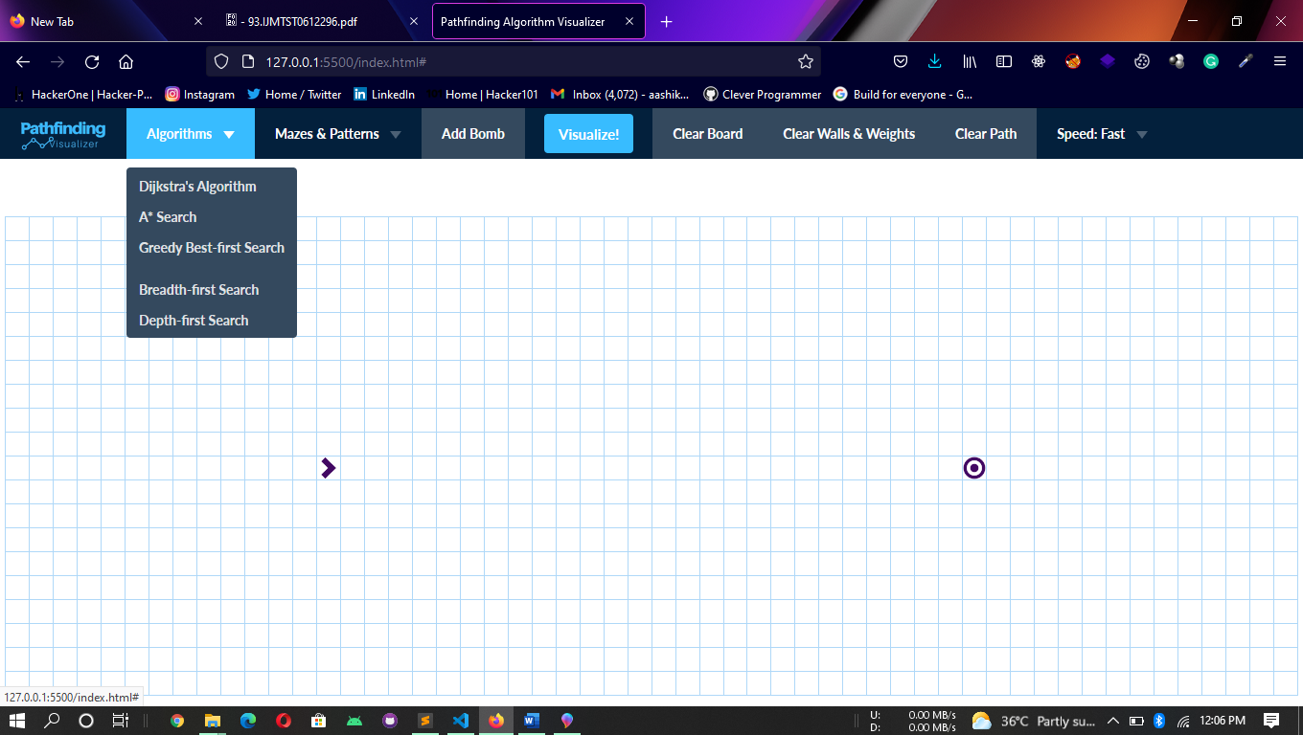

* Click Visualize button to start.

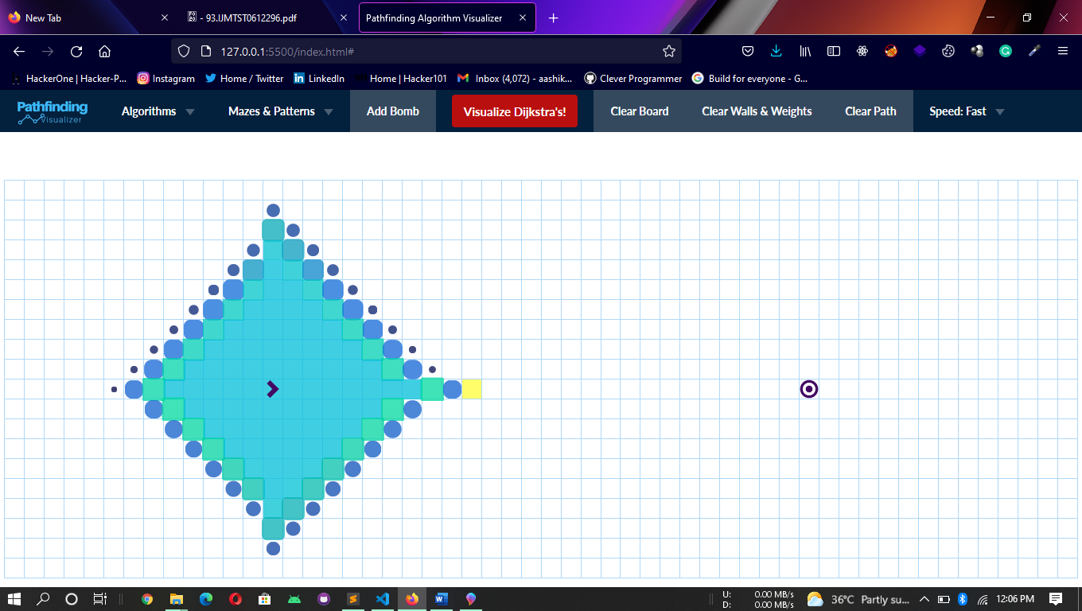

# TABLE:

## CHAPTER 6

**PERFORMANCE ANALYSIS AND COMPARISION**

|  |  |
| --- | --- |
| ALGORTITHM | TIME(s:ms) |
| Dijkstra’s Algorithm | 21:26 |
| A Star Algorithm | 1:45 |
| Greedy Best-First Search | 1:34 |
| Breadth-First Search | 21:85 |
| Depth-First Search | 7:14 |

<!--index.html-->

## CHAPTER 7 SAMPLE SOURCE CODE

<html>

<head>

<title>Pathfinding Algorithm Visualizer</title>

<link

rel="stylesheet" href="https://maxcdn.bootstrapcdn.com/bootstrap/3.3.7/css

/bootstrap.min.css"

/>

<link id="cssTheme" rel="stylesheet" href="public/styling/c ssBasic.css" />

<link

rel="shortcut icon" type="image/png" href="public/styling/c_icon.png"

/>

</head>

<body>

<div id="navbarDiv">

<nav class="navbar navbar-inverse" style="background- color: #03203c">

<div class="container-fluid">

<div class="navbar-header">

<a id="refreshButton" class="navbar-brand" href="#"

><img

src="./public/styling/logo.png" alt=""

width="90px" height="30px"

/></a>

</div>

<ul class="nav navbar-nav" style="background- color: #03203c">

<li class="dropdown">

<a class="dropdown-toggle" data- toggle="dropdown" href="#"

>Algorithms <span class="caret"></span

></a>

<ul class="dropdown-menu">

<li id="startButtonDijkstra">

<a href="#">Dijkstra's Algorithm</a>

</li>

<li id="startButtonAStar2"><a href="#">A* Searc

h</a></li>

<li id="startButtonGreedy">

<a href="#">Greedy Best-first Search</a>

</li>

<li id="startButtonAStar"><a href="#"></a></li>

<li id="startButtonAStar3">

<a href="#"></a>

</li>

<li id="startButtonBidirectional">

<a href="#"></a>

</li>

<li id="startButtonBFS">

<a href="#">Breadth-first Search</a>

</li>

<li id="startButtonDFS"><a href="#">Depth-

first Search</a></li>

</ul>

</li>

<li class="dropdown">

<a class="dropdown-toggle" data- toggle="dropdown" href="#"

>Mazes &amp; Patterns <span class="caret"></spa

n

></a>

<ul class="dropdown-menu">

<li id="startButtonCreateMazeTwo">

<a href="#">Recursive Division</a>

)</a>

ew)</a>

/a></li>

</li>

<li id="startButtonCreateMazeThree">

<a href="#">Recursive Division (vertical skew

</li>

<li id="startButtonCreateMazeFour">

<a href="#">Recursive Division (horizontal sk

</li>

<li id="startButtonCreateMazeOne">

<a href="#">Basic Random Maze</a>

</li>

<li id="startButtonCreateMazeWeights">

<a href="#">Basic Weight Maze</a>

</li>

<li id="startStairDemonstration">

<a href="#">Simple Stair Pattern</a>

</li>

</ul>

</li>

<li id="startButtonAddObject"><a href="#">Add Bomb<

<li id="startButtonStart">

<button id="actualStartButton"

class="btn btn-default navbar-btn" type="button"

>

Visualize!

</button>

</li>

<li id="startButtonClearBoard"><a href="#">Clear Bo ard</a></li>

<li id="startButtonClearWalls">

<a href="#">Clear Walls &amp; Weights</a>

</li>

h</a></li>

/li>

<li id="startButtonClearPath"><a href="#">Clear Pat

<li class="dropdown">

<a

id="adjustSpeed" class="dropdown-toggle" data-toggle="dropdown" href="#"

>Speed: Fast <span class="caret"></span

></a>

<ul class="dropdown-menu">

<li id="adjustFast"><a href="#">Fast</a></li>

<li id="adjustAverage"><a href="#">Average</a><

<li id="adjustSlow"><a href="#">Slow</a></li>

</ul>

</li>

</ul>

</div>

</nav>

</div>

<div id="tutorial">

<h3>Welcome to Pathfinding Visualizer!</h3>

<p>

Visualizations of algorithms contribute to improving co mputer science

education. The process of teaching and learning of algo rithms is often

complex and hard to understand problem. Visualization i s a useful

technique for learning in any computer science course.

The algorithms

are <br />=>Dijkstra's Algorithm <br />=>A * Search <br

/>=>Greedy

Best-First Search <br />=>Breadth- first Search <br />=>Depth-first

Search

</p>

<div id="tutorialCounter">1</div>

<button id="skipButton"

class="btn btn-default navbar-btn" style="background-color: #38bcff" type="button"

>

Get Started

</button>

</div>

<div id="mainGrid">

<div id="mainText"></div>

<div id="algorithmDescriptor"></div>

<table id="board" />

</div>

</body>

<script src="https://ajax.googleapis.com/ajax/libs/jquery/3.1

.1/jquery.min.js"></script>

<script src="https://maxcdn.bootstrapcdn.com/bootstrap/3.3.7/ js/bootstrap.min.js"></script>

<script src="public/browser/bundle.js"></script>

</html>

## Full Source code:

<https://github.com/aashikm015/PathfindingAlgorithmVisualizer.git>

## CHAPTER 8 CONCLUSION

With the completion of this project, we have successfully achieved our objective of our project is to embed Graph Path Finding with Visualization and Comparing their performance.

As is the case with most other teaching areas, there has been a significant gap between the theory and practical understanding of algorithms realization. This is true also for shortest paths algorithms and in particular for Dijkstra algorithm.

The main goal of the project is to use it from operations research educators and students for teaching and studying the existing known combinatorial graph algorithms.

The main idea of the system is to provide an integrated educational environment for both instructors and students to facilitate the learning process in efficient way.

To conclude, we have learnt a lot of things working under this project. We are also thankful to our mentor and supervisor for their efforts in the learning process.

## CHAPTER 9 REFERENCES

1. https:/[/www.geeksforgeeks.o](http://www.geeksforgeeks.org/graph-data-stru)r[g/graph-data-stru](http://www.geeksforgeeks.org/graph-data-stru) cture-and-algorithms/
2. https://medium.com/swlh/pathfinding-algorith

ms-6c0d4febe8fd#:~:text=What%20are%20Pathfin ding%20Algorithms%3F,based%2 0on%20some%20predefined%20criteria.

1. https://en.wikipedia.org/wiki/Pathfinding 4.https:/[/www.w3schools.co](http://www.w3schools.com/js/)m[/js/](http://www.w3schools.com/js/)

5.https:/[/www.me](http://www.meta-chart.com/histogram)t[a-chart.com/histogram](http://www.meta-chart.com/histogram) 6.https:/[/www.geeksforgeeks.o](http://www.geeksforgeeks.org/dijkstras-)r[g/dijkstras-](http://www.geeksforgeeks.org/dijkstras-) shortest-path-algorithm-greedy-algo-7/

1. https:/[/www.geeks](http://www.geeksforgeeks.org/a-search-algorithm/)f[orgeeks.org/a-search-algorithm/](http://www.geeksforgeeks.org/a-search-algorithm/)
2. https://[www.researchgate.net/publication/282488307_Pathfinding_Algorithm_Effic](http://www.researchgate.net/publication/282488307_Pathfinding_Algorithm_Effic) ciency_Analysis_in_2D_Grid
3. <http://tesi.fabio.web.cs.unibo.it/twiki/pub/Tesi/DocumentiRitenuti>Utili/p80-ardito.pdf
4. Ahuja R. K., Magnanti, T. L. & Orlin, J. B.(1993). Network Flows: Theory,Algorithms and Applications. Englewood Cliffs, NJ: Prentice Hall.
5. Dijkstra, E. W. (1959). A Note on Two Problems in Connection with Graphs. Numeriche Mathematik, 1, 269-271.
6. Fouh E., Akbar M. & Shaffer C. A. (2012). The Role of Visualization in Computer Science Education. Computers in the Schools, 29(1-2), 95-117.
7. Roles J.A. & ElAarag H. (2013). A Smoothest Path algorithm and its visualization tool. Southeastcon, In Proc. of IEEE, DOI: 10.1109/SECON.2013.6567453.
8. Paramythis A., Loidl S., Mühlbacher J. R., & Sonntag M. (2005). A Framework for Uniformly Visualizing and Interacting with Algorithms. In Montgomerie, T.C., & Parker E-Learning, J.R. (Eds.), In Proc. IASTED Conf. on Education and Technology (ICET 2005), Calgary, Alberta, Canada, 2-6 July 2005, pp. 28- 33.